20 November 2017

Dear Sir / Madame:

In celebration of the **2018 Nihongo Fiesta**, we are pleased to invite you to the **“10th Nihongo Quiz Bee for High School Students**”, an event of the Japan Foundation, Manila and the Association of Filipino Nihongo Teachers (AFINITE). It will be held on **17 February 2018 (Saturday)** – as part of the morning’s featured activities, at the **Shangri-La Plaza**, EDSA, Corner Shaw Boulevard, Mandaluyong City.

The Nihongo Quiz Bee is open to Filipino high school students currently attending Nihongo or Japanese Language & Culture classes in their respective schools. The Nihongo Quiz Bee aims to showcase their knowledge in Japanese language and culture. Those who are **eligible to participate are** **Nihongo students**,

1. who have not yet joined any Nihongo Quiz Bee from 2009 to 2017 as either main or alternate contestants;
2. who have not yet joined and will not join in other Japan Foundation events like the Japanese Speakers’ Forum;
3. who have not stayed in Japan for an accumulated / total period of more than 6 months;
4. who have not yet passed any of the 5 levels of the Japanese Language Proficiency Test (JLPT) and who have not taken the December 2017 JLPT exam;
5. whose parents/either father or mother are/is not Japanese national(s); and
6. who are **currently** **enrolled** in Japanese Language & Culture classes **in their respective high schools.**

Deadline for the submission of duly accomplished application forms and pictures for the “additional requirements” is on **12 December 2017 (Tuesday).** **Changes in the participants and Official Coach will not be entertained after all papers have been submitted. Only one teacher will be recognized as Official Coach from each school. Moreover, Nihongo Partners will be asked to make questions so they are not allowed to coach the students and they will not be recognized as coach. Please adhere to the deadline and rules strictly. Forms submitted after the deadline will not be accepted for any reasons and violation of the rules will result to disqualifications.**

For details and clarifications, please contact The Japan Foundation, Manila at

tel. # (02)811-6155 to 58 / e-mail: nihongoquizbee@gmail.com.

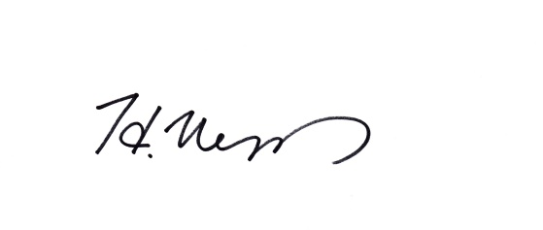Anticipating with thanks your support and cooperation on this cultural endeavor; we are looking forward to seeing you all.

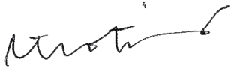

HIROAKI UESUGI Katharine R. Teotico

Director, The Japan Foundation, Manila President, AFINITE

**10th Nihongo Quiz Bee for High School Students**

**REGISTRATION FORM**

Photo

(within 6 months)

2 - alternate

Photo

(within 6 months)

1 - main

Please complete this form e-mail to:

**The Japan Foundation, Manila**

**E-mail:** **nihongoquizbee@gmail.com**

Please fill out clearly in **BLOCK** style (please print) and submit on or before **12 December 2017 (Tuesday)**

|  |  |  |  |  |
| --- | --- | --- | --- | --- |
|  | Family Name First Name M.I. | Date of Birth | Year Level | Sex |
| main contestant |  |  |  | M / F |
| alternate |  |  |  | M / F |

1. **School / Institution :**

Principal:

Address:

Tel. # / fax # : E-mail :

1. **2018 Quiz Bee Official Coach:**

CP# E-mail:

1. **\*For PRIVATE SCHOOLS ONLY:**

Number of Japanese teacher/s: (Number of Native Japanese teacher/s )

Total number of students taking Japanese:

Year level offering Nihongo classes (please encircle): Grade 7/ Grade 8/ Grade 9/ Grade 10

Main textbook being used:

Conformé:

Principal Coordinator Official Coach

Signature over printed name Signature over printed name Signature over printed name

**Principal and Official Coach’s Copy**

**10th Nihongo Quiz Bee for High School Students**

**Additional Requirements / Information**

Re: 10th Nihongo Quiz Bee for High School Students

Please send photographs for the official Facebook page of JFM (<https://www.facebook.com/jfmanila?ref=hl>) and for the Nihongo Quiz Bee slideshow presentation. In view thereof, please confirm your consent / permission to allow JFM to post the photos of student participants in the JFM’s bi-annual newsletter “Merienda” as well as on the official Facebook page of JFM by signing this form (conformé).

Additional requirements

A：For the JFM Facebook page

**Half-body photograph of both contestants:**

* **Doing any “I-will-do-my-best” pose**
* **Wearing the school uniform**

*Refer to sample.

B：For the Nihongo Quiz Bee slideshow presentation：

**3-5 photographs of your school’s Nihongo related activities**

Please send all high resolution (clear and bright) photographs in **jpeg format** to **nihongoquizbee@gmail.com**

**Deadline for all requirements: 12 December 2017 (Tuesday)**

I hereby allow The Japan Foundation, Manila to use the photos submitted by the participant/s in the Japan Foundation, Manila’s bi-annual newsletter “Merienda” as well as on the official Facebook page of JFM (<https://www.facebook.com/jfmanila?ref=hl>).

Conformé:

Name of School: ________________________________________________________________________

　　Signature over printed name Signature over printed name

PRINCIPAL OFFICIAL COACH

**Parent/Guardian’s Copy ①**

**10th Nihongo Quiz Bee for High School Students**

**Additional Requirements / Information**

Re: 10th Nihongo Quiz Bee for High School Students

Please send photographs for the official Facebook page of JFM (<https://www.facebook.com/jfmanila?ref=hl>) and for the Nihongo Quiz Bee slideshow presentation. In view thereof, please confirm your consent / permission to allow JFM to post the photos of student participants in the JFM’s bi-annual newsletter “Merienda” as well as on the official Facebook page of JFM by signing this form (conformé).

Additional requirements

A：For the JFM Facebook page

**Half-body photograph of both contestants:**

* **Doing any “I-will-do-my-best” pose**
* **Wearing the school uniform**

*Refer to sample.

B：For the Nihongo Quiz Bee slideshow presentation：

**3-5 photographs of your school’s Nihongo related activities**

Please send all high resolution (clear and bright) photographs in **jpeg format** to **nihongoquizbee@gmail.com**

**Deadline for all requirements: 12 December 2017 (Tuesday)**

I hereby allow The Japan Foundation, Manila to use the photos submitted by the participant/s in the Japan Foundation, Manila’s bi-annual newsletter “Merienda” as well as on the official Facebook page of JFM (<https://www.facebook.com/jfmanila?ref=hl>).

Conformé:

Name of School: _____________________________________________________________________________

Student’s Guardian : _____________________________ Student’s name : ____________________________

Signature over printed name

**Parent/Guardian’s Copy ②**

**10th Nihongo Quiz Bee for High School Students**

**Additional Requirements / Information**

Re: 10th Nihongo Quiz Bee for High School Students

Please send photographs for the official Facebook page of JFM (<https://www.facebook.com/jfmanila?ref=hl>) and for the Nihongo Quiz Bee slideshow presentation. In view thereof, please confirm your consent / permission to allow JFM to post the photos of student participants in the JFM’s bi-annual newsletter “Merienda” as well as on the official Facebook page of JFM by signing this form (conformé).

Additional requirements

A：For the JFM Facebook page

**Half-body photograph of both contestants:**

* **Doing any “I-will-do-my-best” pose**
* **Wearing the school uniform**

*Refer to sample.

B：For the Nihongo Quiz Bee slideshow presentation：

**3-5 photographs of your school’s Nihongo related activities**

Please send all high resolution (clear and bright) photographs in **jpeg format** to **nihongoquizbee@gmail.com**

**Deadline for all requirements: 12 December 2017 (Tuesday)**

I hereby allow The Japan Foundation, Manila to use the photos submitted by the participant/s in the Japan Foundation, Manila’s bi-annual newsletter “Merienda” as well as on the official Facebook page of JFM (<https://www.facebook.com/jfmanila?ref=hl>).

Conformé:

Name of School: _____________________________________________________________________________

Student’s Guardian : _____________________________ Student’s name : ____________________________

Signature over printed name

Sample picture of Additional requirement A

*Half-body photograph of both contestants doing the “I-will-do-my-best” pose

The background should be plain/blank!

Face and body are easy to identify.

Good Sample!



All parts of the subject should be clearly seen!

Picture should be bright and clear!

Faces can be seen very well!

Two of them stand far away from each other.

Dark and

not clear…

Two of them stand far away from each other.

Dark and

not clear…

Two of them stand far away from each other.

Dark and

not clear…

Two of them stand far away from each other.

Dark and

not clear…

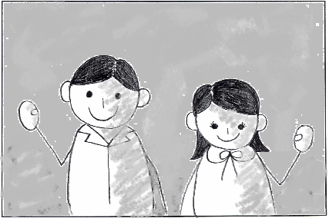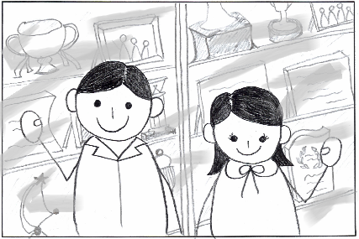

Bad samples!

Two of them stand far away from each other.

Dark and

not clear…

The background is complicated.

Part of the head is cut off…

Students should wear School uniform.

NOT P.E. uniform.

Any “I-will-do-my-best” pose is OK!

Be creative!

Checklist of Requirements to be Submitted for the

“10th Nihongo Quiz Bee for High School Students”

* 10th Nihongo Quiz Bee for High School Students REGISTRATION FORM

(with both contestants’ Photo within 6 months)

* 10th Nihongo Quiz Bee for High School Students Additional Requirements / Information’s Signed Conformé from Principal and Official Coach
* 10th Nihongo Quiz Bee for High School Students Additional Requirements / Information’s Signed Conformé from Student’s guardian **×2**)
* Half-body photograph of both contestants for the JFM Facebook page. Please refer to sample.
* **3-5** candid photographs of your school’s Nihongo related activities in jpeg format for the Nihongo Quiz Bee slideshow presentation

**Deadline for all requirements: 12 December 2017 (Tuesday)**

**Please send all pertinent papers on or before the deadline to:**

[nihongoquizbee@gmail.com](mailto:nihongoquizbee@gmail.com)

**with the title, “Quiz Bee Registration Forms from (name of school)”**